THE COMPUTER CASE
The term system board can be used to describe any number of circuit boards that make up the internals of your computer, but it is used most often to describe the motherboard. The motherboard is the main board in your computer that contains the BIOS chips, RAM, I/O ports, and CPU. This board maintains the electrical pathways that enable all other components to communicate with each other.
MOTHERBOARD FORM FACTORS
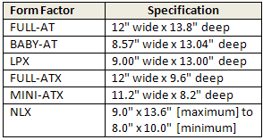

THE EXPANSION SLOTS
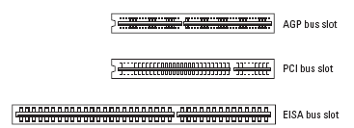
AT AND ATX DIFFERENCES
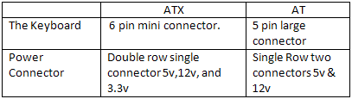

THE COMPUTER motherboard

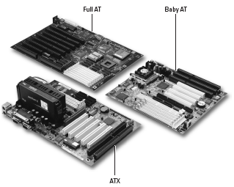
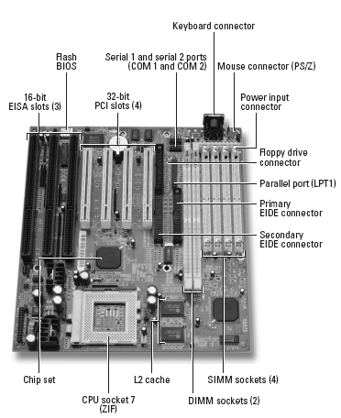

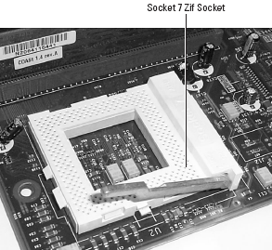
MOTHERBOARD COMPONENTS
CPU ZIP SOCKET

Processor
One of the easiest items to recognize on the motherboard is the processor. The processor is usually the largest chip on the system board and can be identified generally because it often has a heat sink or fan located on top of it.

memory
There are typically two types of sockets to install memory: SIMM (Single InLine Memory Module) sockets and DIMM (Dual Inline Memory Module) sockets. Original Pentium systems typically have either four 72-pin SIMM sockets, or two 168-pin DIMM sockets to install memory.

Expansion Slots
Most motherboards have one or more expansion slots, which serve the purpose of adding functionality to the computer. Even if, for example, your computer doesn’t have sound capability right now, you can install a sound card into the expansion slot to add that capability. Expansion slots come in different varieties on systems today, and it is extremely important to understand the benefits of each type.

SIMM/DIMM SOCKETS

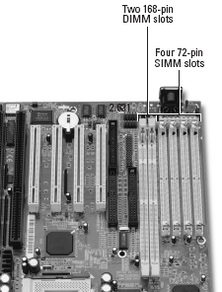

POWER CONNECTOR
Located on the system board, you should see a type of
connector that you can use to connect the power supply to the Motherboard. All of these devices connected to the motherboard need to get power from somewhere, so the power supply is connected to the motherboard, which supplies power to the board and its components.

EXPANSION SLOTS

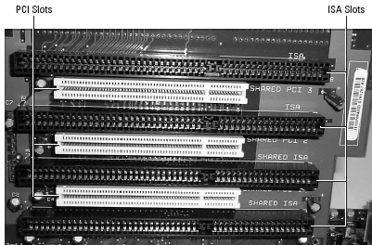
COMMUNICATION PORTS

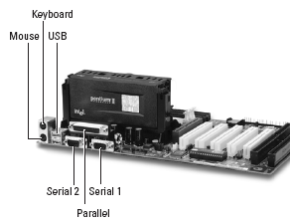

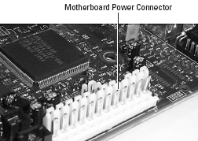
POWER CONNECTOR

MOTHERBOARD COMPONENTS
Floppy disk controller
Located very close to the hard disk controllers, you should see a smaller floppy drive controller that connects the floppy drive to the motherboard. This controller supports a 33-wire ribbon cable, which connects the floppy drive to the motherboard.

BIOS chip
Locating the BIOS chip on the system board is easy; it is usually rectangular in shape and generally features the manufacturer’s name as a label on the chip. Some of the popular manufacturers are AMI, AWARD, and IBM. The Basic Input Output System (BIOS) is the low-level program code that allows all the system devices to communicate with one another. This low-level program code is stored in the BIOS chip on the motherboard.

FLOPPY DISK CONTROLLER

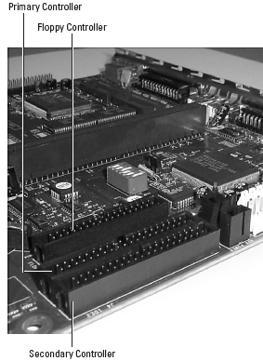
CMOS BATTERY
The computer keeps track of its inventory in what is known as Complementary Metal Oxide Semiconductor (CMOS). CMOS is a listing of system components, such as the size of the hard disk that is installed in the computer, the amount of RAM, and the resources used by the serial and parallel ports.

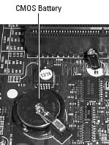
CMOS BATTERY

BIOS CHIP

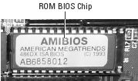

EXPANSION SLOT TYPES
The Industry Standard Architecture (ISA) was the first major expansion bus architecture that was originally developed as an 8-bit architecture and then a 16-bit architecture. The ISA bus architecture had a speed of 8 MHz, which is extremely slow when looking at the speed of processors and other system components today.

The Peripheral Component Interconnect (PCI) is one of the newer bus architectures that hit the market. PCI has two flavors: 32-bit cards and 64-bit cards. The PCI bus has a speed of 33 MHz and also supports bus mastering. One of the major benefits of PCI is that it is a plug and play architecture.

The Advanced Graphics Port (AGP) has been around since the Pentium II processor in 1997 and runs at 66 MHz, which is double the speed of the PCI bus. Today’s motherboards have one AGP slot to insert an AGP video card. The performance gain from the AGP port not only comes from the increase in speed, but also the fact that the AGP bus has a direct path to the processor so that information travels quickly from the processor to the AGP card.

